Private Catalog Overview
One of the key features in PSS is the ability to load your own catalog data by using our Custom Product Uploader. This may be used for brands that do not work with the major Powersports distributors, or for parts that you produce on your own and wish to sell on the various marketplaces.
Before we get started let us go over terminology and outline some things that you need to account for prior to importing catalog data into PSS, and ultimately listing it up on the various marketplaces for sale.

Web Ready Data
Getting catalog data in a usable format that translates into an easy purchasing experience for shoppers on any eCommerce platform is no easy task. More people fail at it than succeed. How you format your data matters. If you rush through it and don't give it the attention that it requires you can expect lackluster results on any eCommerce platform. PSS has spent years helping dealers get their Private Catalog Data to perform on various marketplaces and we feel that we have a very user-friendly system in place compared to other tools.

Add Product with the UI
We updated the Private Catalog user interface in the summer of 2019 and the feedback from dealers has been fantastic. As long as you have a basic understanding of Product Grouping and are able to click and type you should have no problems. The UI essentially takes the fields from the CSV file and puts them in a more visually pleasing format allowing you to visualize the product better. Images are also previewed upon input.

Import Product with CSV Files
The PSS user interface does allow you to easily add a Private Catalog product however, it is not optimal for adding tens, hundreds, or thousands of products. Microsoft Excel remains the best way to manage catalog data and PSS allows you to easily import these files. What separates the good data from bad has to do with formatting and product associations. Make sure you take the time to learn our template header and the concept of Product Grouping.

Products vs Product Groups
The PSS Catalog Team groups similar products with different attributes together so that they can display on a marketplace with dropdowns or attribute selectors.
A Product is an MPN. There is only one MPN per product.
A Product Group is all the different variations of a single product. There are multiple MPNs in a Product Group.
In this example below, you see that all of these products have the same Name. This is the Product Group Name. Also notice how each line has a unique MPN, Size, Color. Each size/color variant has its own MPN.
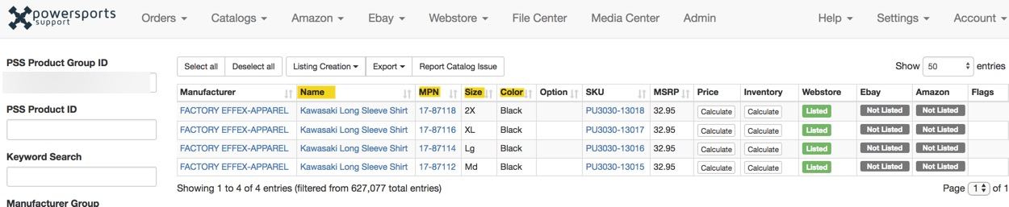

Sizes, Colors, Options
The PSS database breaks out attributes so that they can be filtered on a marketplace and worked into various parts of an eCommerce product page with tags. If the products you are working with have a size, color or option, you will want to make sure that you assign the attribute to the proper column. This way when you list products on say, eBay, your variation listings will have drop-down choices.

Product and Product Group Best Practices
- Make sure the spelling a naming of your product groups is accurate
- Use Proper Capitalization. Don't do all caps!
- Make sure your entries do not have any trailing spaces that would cause the cell to be unique
- Make sure that your MPNs are accurate and only appear once
- DO NOT use different formats or spelling for attributes. If you use Yellow, continue to use Yellow. Don't start using YLW. Keep your cataloging methods consistent.
- DO NOT put size, color, option attributes in your Product Group Name.
- DO NOT put Manufacturer Group in your Product Group Names.
- DO NOT put fitment into your Product Group Names. Use the Private Catalog Import Fitment feature.
- Take your time. Do it right the first time.

Available Inventory
At PSS we have made a business by automating inventory and making sure that accurate quantities are pulled from the distributor or dealer hosted FTP, and updated a minimum of once per day. Anyone can list a product for sale but it is your ability to only allow people to purchase an in-stock product that remains the biggest factor in long-term eCommerce success.
Each marketplace place has a different level of risk, reward, and a penalty for accurate inventory. Or the lack thereof. Showing an Out of Stock product as In Stock on your webstore, and having someone purchase it isn't going to hurt you too badly. The worst case scenario is the buyer gets frustrated and goes to your Facebook page or Google profile and gives you some bad feedback; still not great.
Now run down that same situation on eBay or Amazon. You still have a great chance to get the negative feedback however it doesn't stop there. You risk having your seller rating dinged, perhaps showing up in fewer product searches, or having your account suspended for a week. All of the sudden your eCommerce business is in the toilet all because buyers were not having a positive experience buying from you.
Bottom line; out of stock sales happen. For the PSS Aftermarket Catalog, we aggregate inventory from every single warehouse for every distributor. Even with allowing sellers buffers for overselling we still get reports of shoppers buying an OOS product. A few Out of Stock sales won't crush you but if you are constantly showing inaccurate inventory it will catch up to you at some point.

