Working with Components
Friday, December 02, 2016
2:28 PM

When accessing an account as an Admin user, the first screen that you come to is the Account Info screen. From here, click on the "Components" button next to the site you wish to work on.

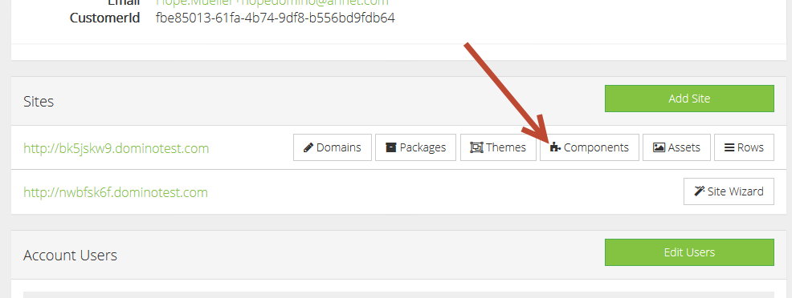

Two tabs will be shown in this area for active and inactive components. Click the "Browse Marketplace" link to add additional components to the site IF AND ONLY IF the proper invoicing has been done for the billing of the additional functionalities.

For active components, click the gear icon to edit the component.

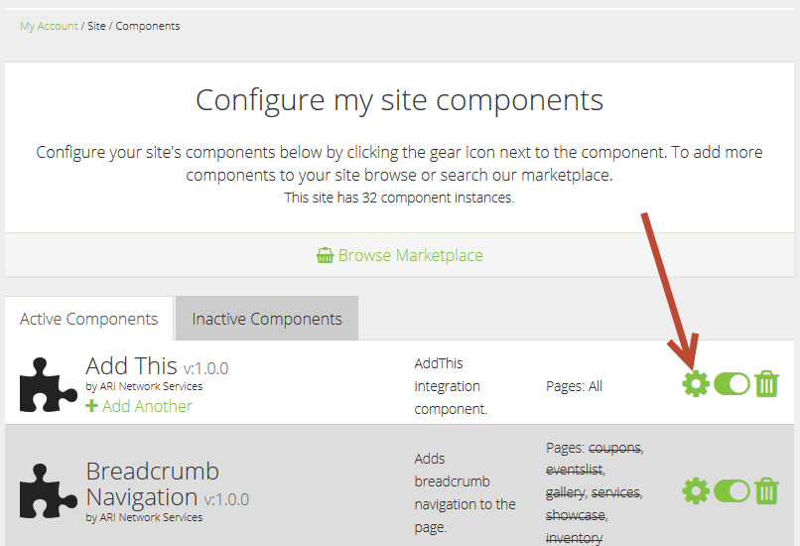

For inactive components, you must first turn the toggle for the component to "On" before it becomes available for editing.

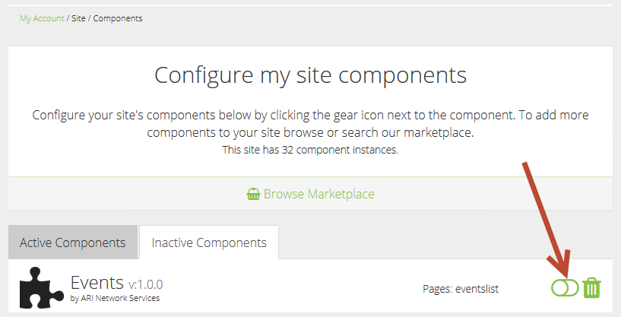

Inactive components with a trash can icon next to them are still configured for the site but not being shown on it. Clicking on the trash can icon will remove the component completely from the site and will reset any configuration done for the component. Once this has been done, the component will show as inactive and will have a toggle switch with no additional icons on that line.

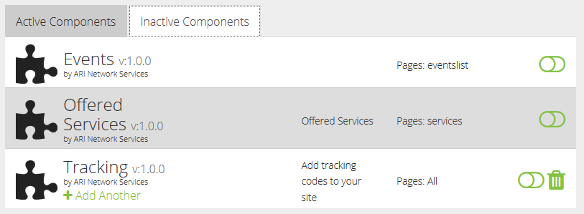

Deactivating a component without deleting it allows the component to be turned back on at a later date with all its data intact.

To add an additional instance of a component, click on the "+ Add Another" link for the specific component that you want. Note: Not all components allow multiple copies, but many do.

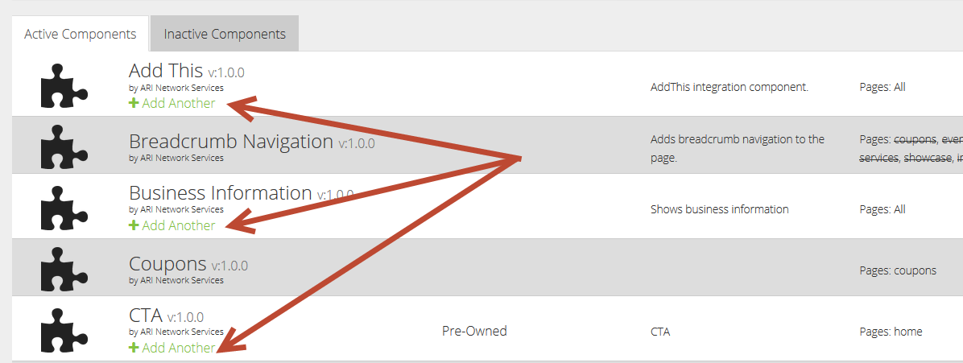

When you have multiple copies of a component and you choose to delete one, that copy will not appear in the Inactive section. That instance of the component will only show in the inactive tab if the toggle for active/inactive is used. The only time a deleted component will show in the Inactive tab is if it was the last active copy of that component.

